TopHat

Monopoly Bot

by Brian O'Leary, Daniel Graham, Conal O'Neill

Bot algorithm description

Rolling

Our bot contains a private Boolean 'hasRolled' used for checking of we have already rolled this turn. If we haven’t yet rolled, then roll and update our Boolean. Otherwise continue through our algorithm.

### Buying

To decide whether to buy an unowned property we land on, we first check our balance to see if we can afford it. We also make sure that it isn't a utility as our strategy is to avoid these properties due to their low return on investment. We have 4 tiers of balance to decide how much money we are willing to spend on a property. These are 300 - 500, 500 - 850, 850 - 1100 and > 1100. If we have greater than 1100, then we will buy any property. We have further price restrictions depending on what tier of balance we are on. We will always buy station properties regardless of balance tier as these have the best return of investment in the game.

### Houses and Hotels

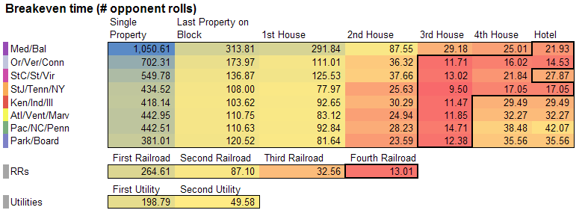Our strategy for building houses is to always aim to have 3 houses as this proves the best return on investment as shown by the following chart:

This strategy and chart was found at http://www.amnesta.net/monopoly/. We found this was a very thorough study of monopoly and so chose to follow elements of this strategy. If our balance is greater than 2500 then we will build more than 3 buildings.

### Getting out of negative balance

Our first resort to get out of negative balance is to demolish any buildings we have as this will disrupt our income the least. Our next strategy is to check if we own any single property that we could mortgage to get out of debt. Our final resort is to begin mortgaging all of our properties starting at the cheapest and cycling through until we either have a positive balance or no more property to mortgage. If this is the case, we will declare bankruptcy.

### Redeeming mortgaged properties

Our strategy for redeeming property is to simply redeem property that we can afford with 100 spare. We always aim to avoid having balance below 100 as to avoid trivial fines rendering us bankrupt.

### In Jail

When in jail, we first check if we have a 'Get out of Jail' card and if so then we use it. We next check if our balance is greater than 300 and if so, we pay the 50 fine and get out of jail. This is to minimise our jail time early in the game. If we failed the first two checks, then we roll for doubles to get out.

### Fine or Chance Decision

To decide whether or not to pay the fine or take a chance card when given the choice, we first calculate the worst-case scenario for taking a chance card. If we can afford to pay the worst-case scenario then we take the chance option. The worst case scenario is found by using our number of houses as the 'building fine' chance card will cost the most.